Practical 2
1. Aim
To launch an Amazon EC2 instance using Amazon Linux, connect to the instance using EC2 Instance Connect, install the Apache web server (httpd), and host a simple HTML webpage.
2. Objective
The objective of this practical is to understand the basic process of deploying a web server on an Amazon EC2 instance. It includes launching a Linux-based EC2 instance, configuring network access, connecting to the instance using EC2 Instance Connect, installing and starting Apache, and serving a static HTML webpage through the instance's public IP address.
3. Requirements
- AWS account
- AWS Management Console
- Amazon EC2
- Amazon Linux
- Web browser
- Internet connection
4. EC2 Instance Configuration
Setting | Configuration
Instance Name | Jaideep-EC2
Application and OS Image | Amazon Linux
Key Pair | jai-test-key
Connection Method | EC2 Instance Connect
Username | ec2-user
Web Server | Apache (httpd)
Web Server Port | 80
Web Directory | /var/www/html
Network Settings
Configure the security group with the following inbound rules:
Type | Protocol | Port | Source Type
SSH | TCP | 22 | Anywhere
HTTP | TCP | 80 | Anywhere
HTTPS | TCP | 443 | Anywhere

Note: Port 22 allows SSH/EC2 Instance Connect access, while port 80 allows the hosted webpage to be accessed through a web browser.
5. Procedure
Step 1: Launch an EC2 Instance
- Log in to the AWS Management Console.
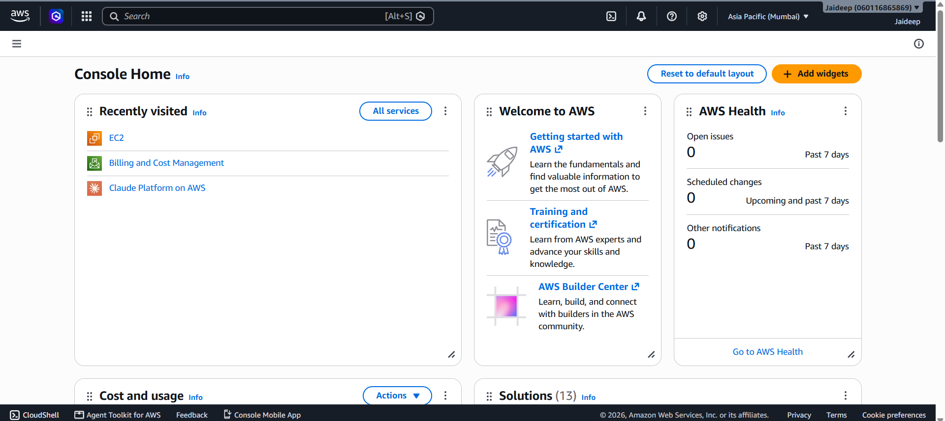
- Open the EC2 service.

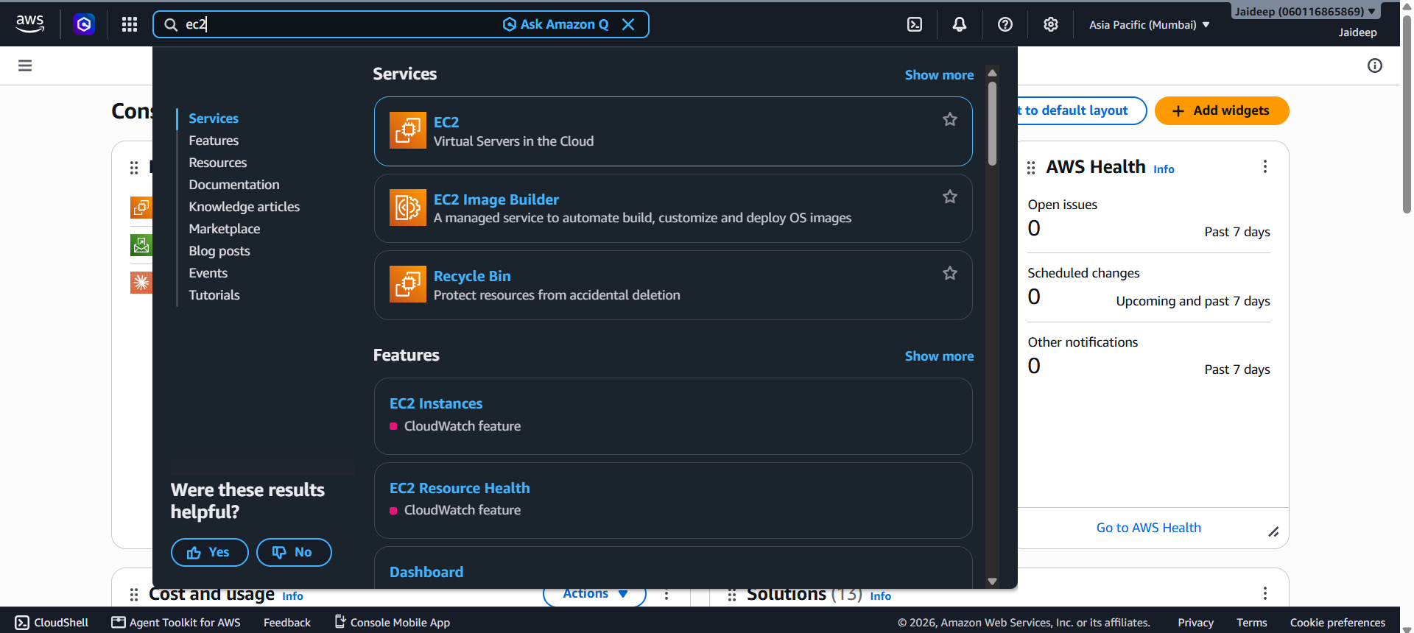
- Select Instances from the navigation panel.
- Click Launch instance.
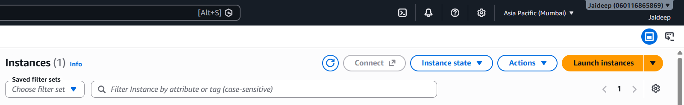
- Enter the instance name:
Jaideep-EC2

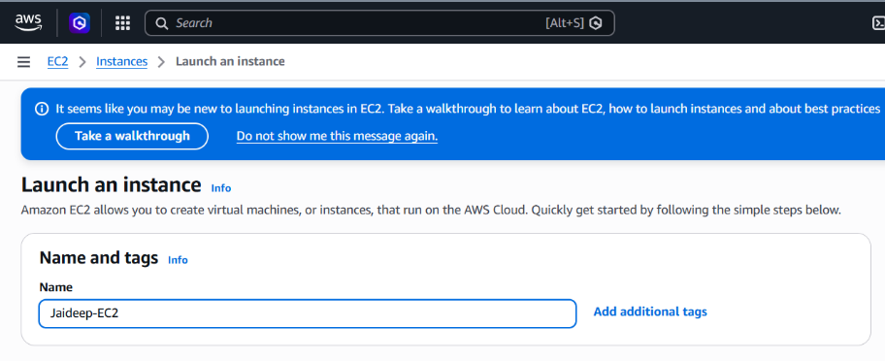
- Under Application and OS Images, select Amazon Linux.
- Leave the Amazon Machine Image (AMI) as unchanged.

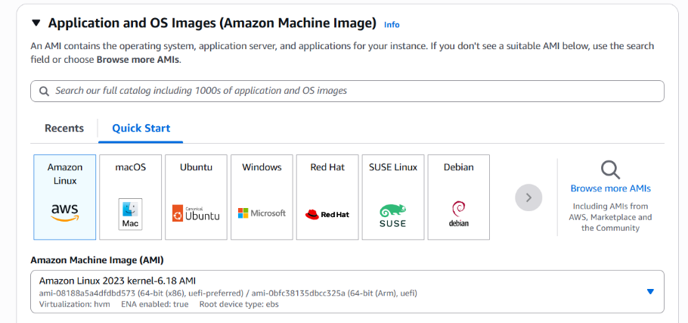
- Under Key pair (login), create a new key pair with the following configuration:
jai-test-key
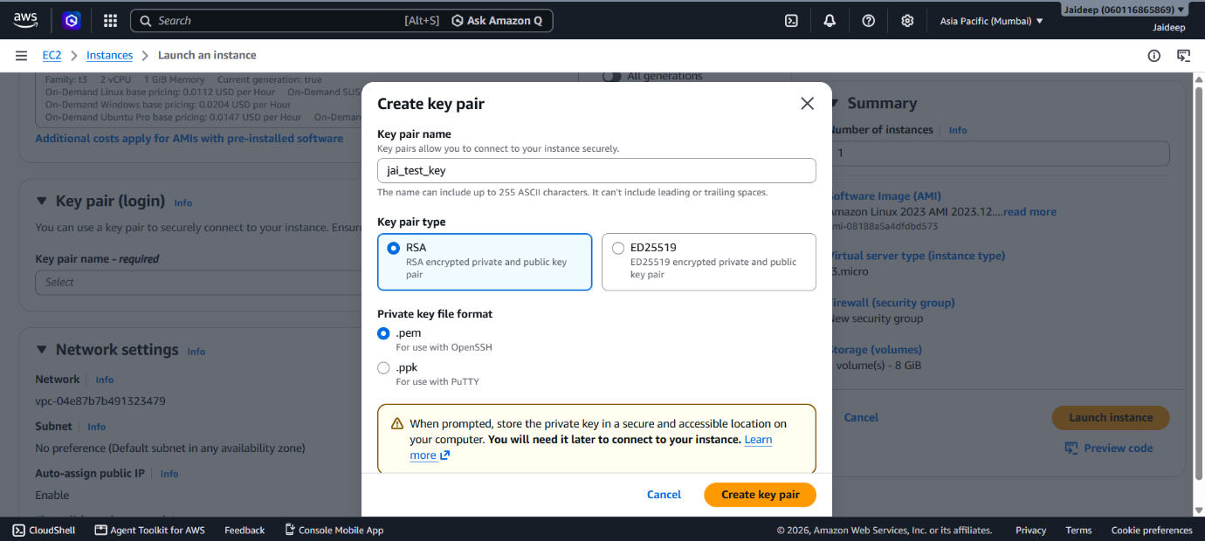
- Under Network settings, click Edit. Under Inbound Security Group Rules, click Add Security Group rule and add the following security group rules below SSH:
  - Type: HTTP (port 80) Source Type: Anywhere Description (optional): Web Server
  - Type: HTTPS (port 443) Source Type: Anywhere Description (optional): Web Server

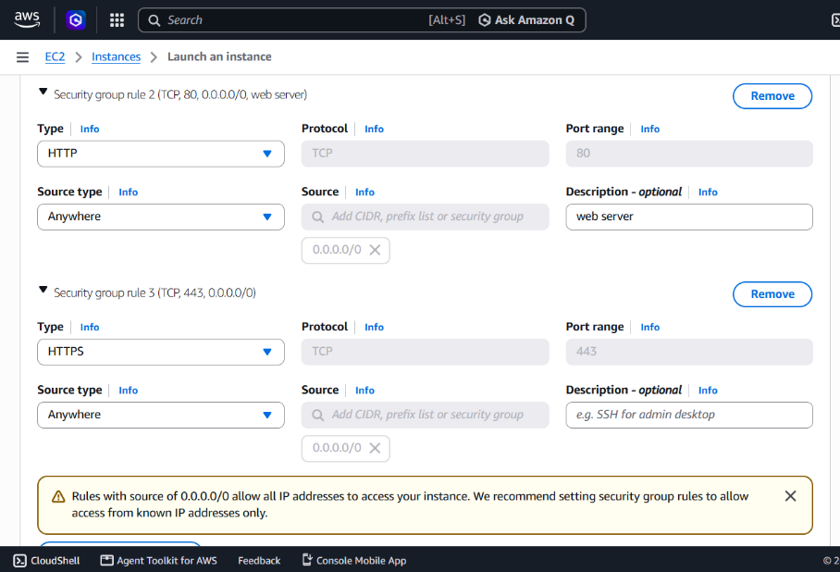
- Leave the remaining settings unchanged/default.
- Click Launch instance.
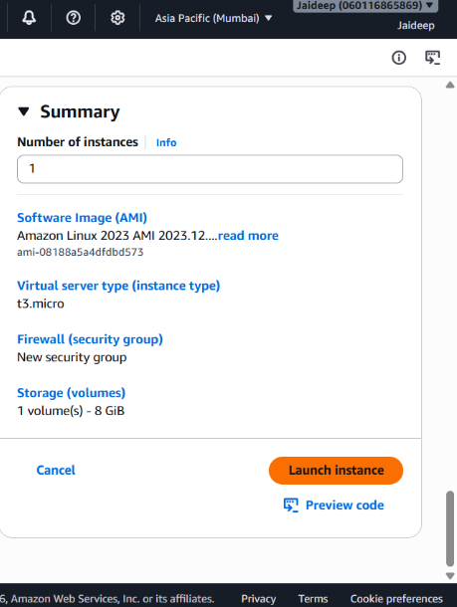

Step 2: Check the Instance
- Go to EC2 → Instances.
- Select Jaideep-EC2.
- Wait until the Instance state shows Running.

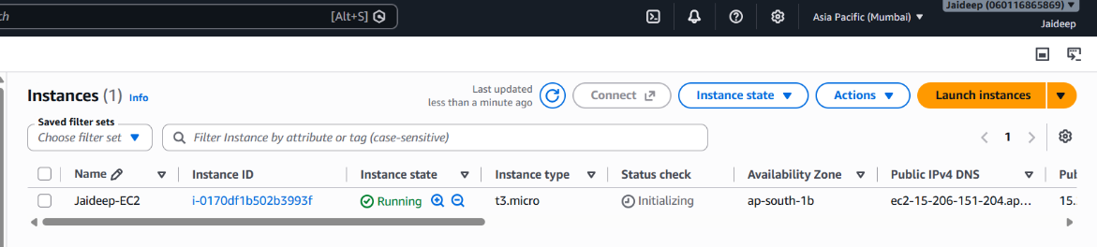
- Note the Public IPv4 address of the instance.
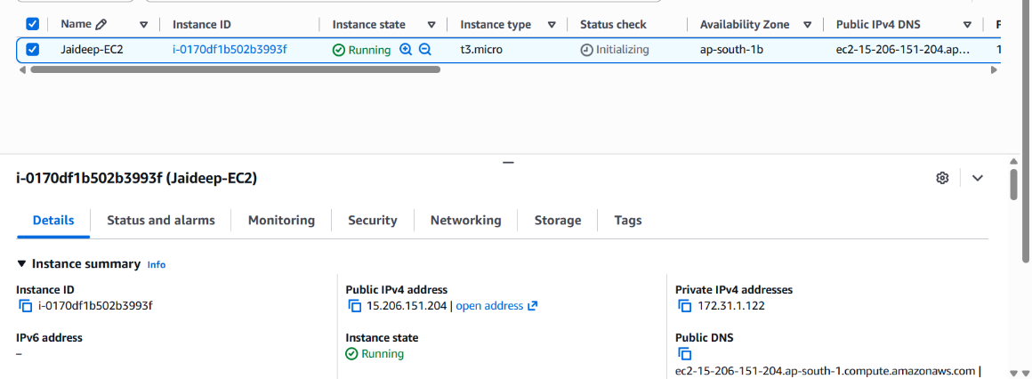
Step 3: Connect Using EC2 Instance Connect
- Select the Jaideep-EC2 instance.
- Click Connect.
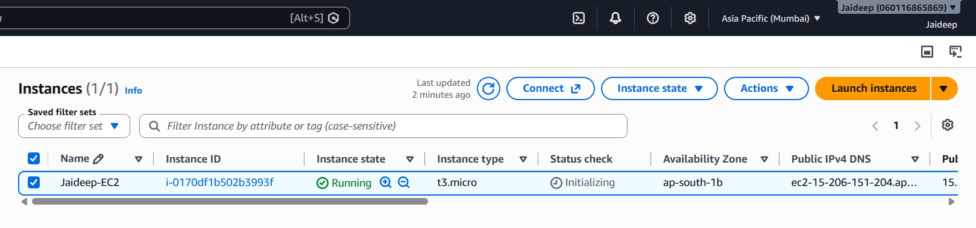
- Select EC2 Instance Connect.
- Select Public subnet access.
- Keep the username as:
ec2-user
- Click Connect.

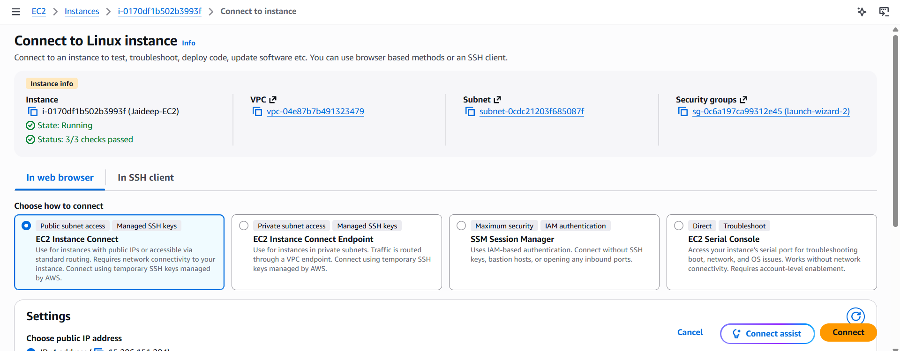
A browser-based terminal opens and provides access to the EC2 instance.
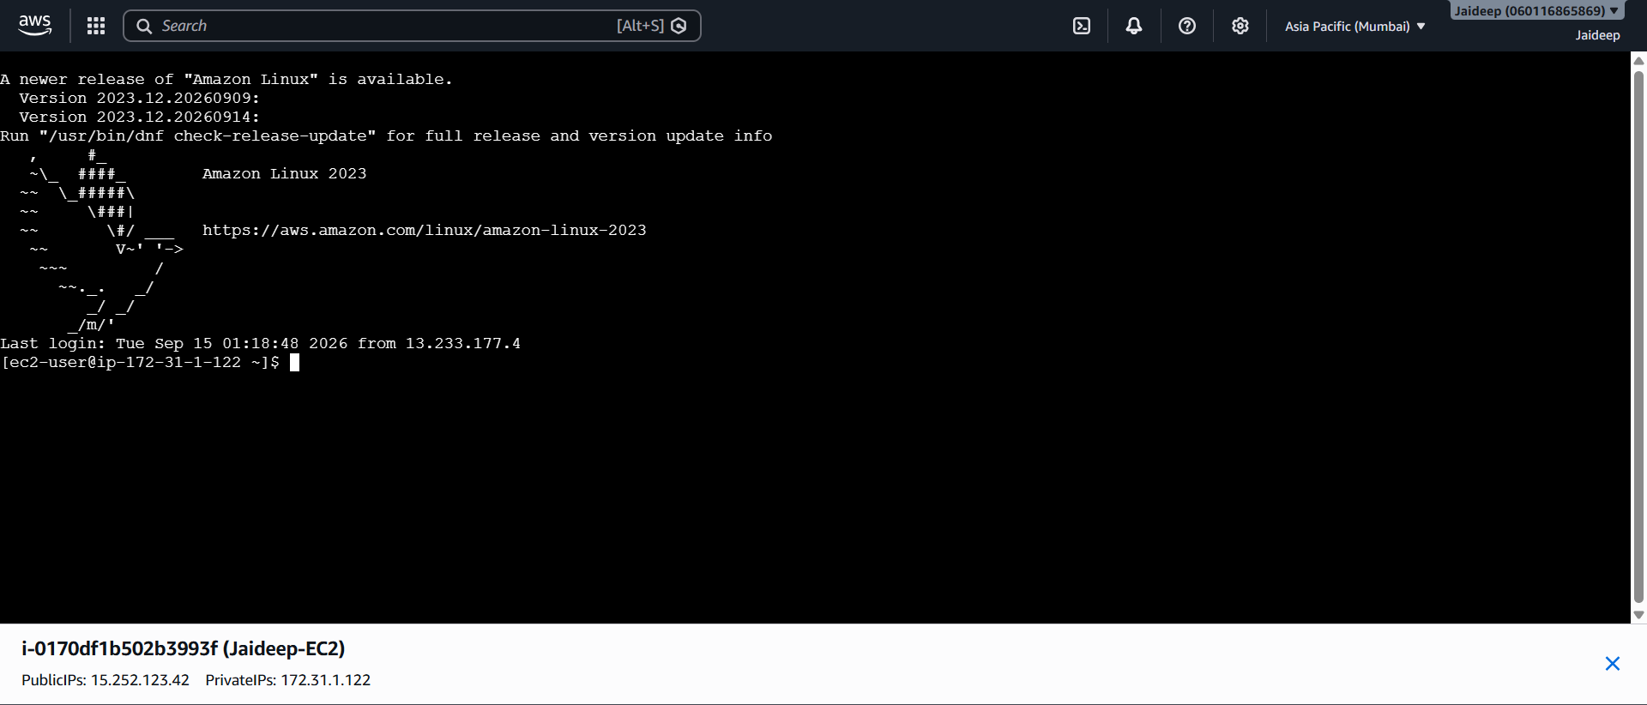
Note: The instance is accessed directly through the AWS Console using EC2 Instance Connect. A separate SSH command from the local computer is not required.
Step 4: Switch to the Root User
In the EC2 Instance Connect terminal, enter:
sudo su -
The terminal switches to the root user.

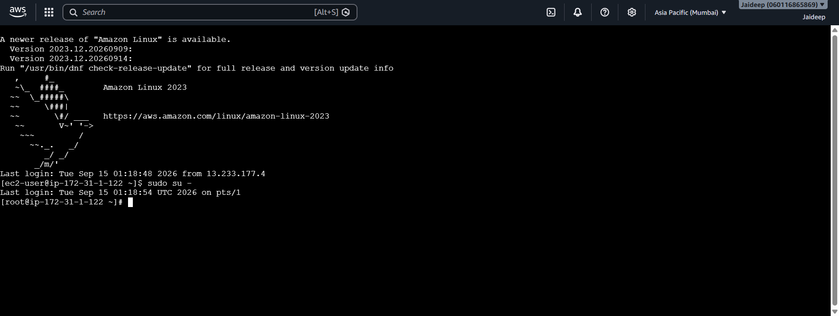
Step 5: Update the System
Run:
yum update
This updates the available packages on the Amazon Linux instance.

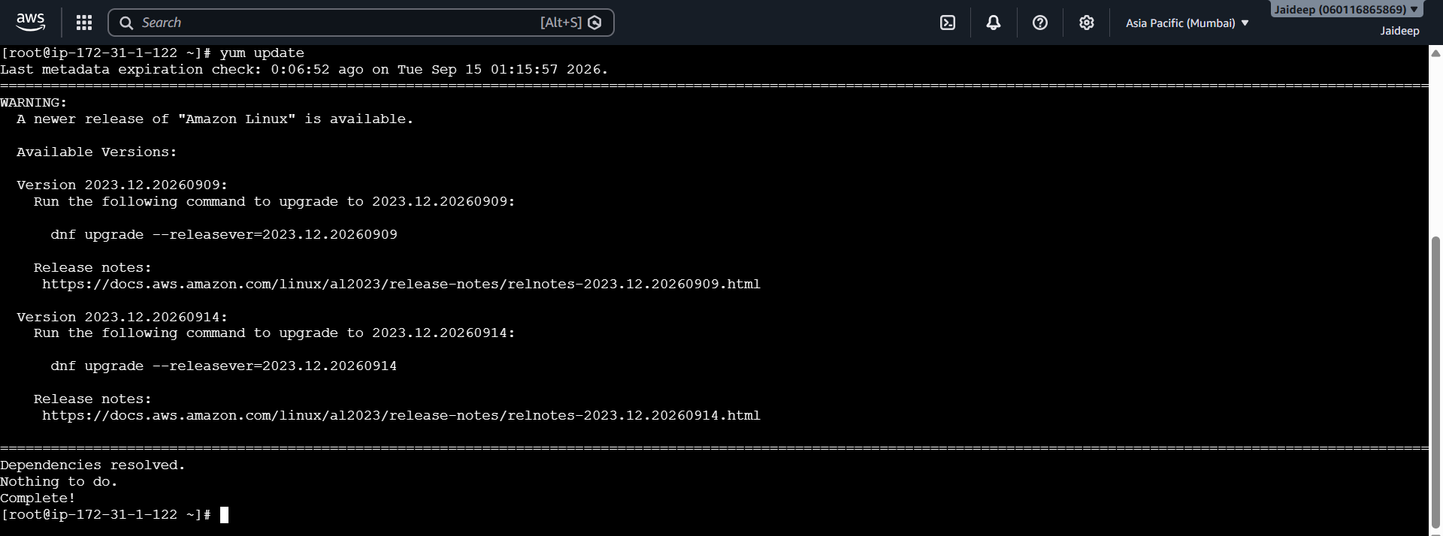
Step 6: Install Apache Web Server
Install Apache using the httpd package:
yum install httpd -y
The -y option automatically confirms the installation.

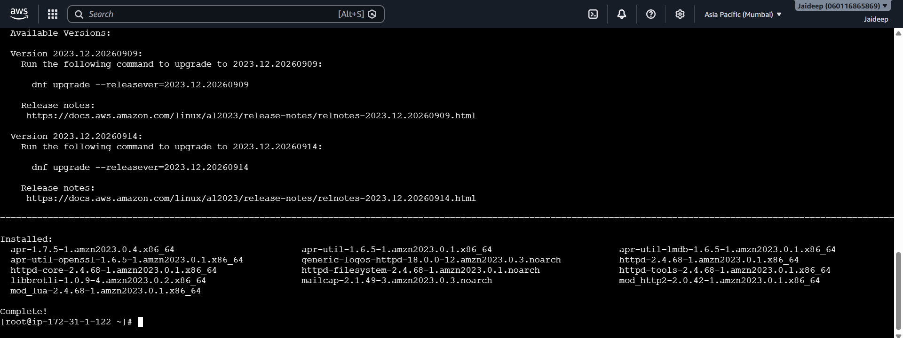
Step 7: Start the Apache Service
Start Apache using:
systemctl start httpd
Check the status of the service using:
systemctl status httpd
The service should show an active/running status.

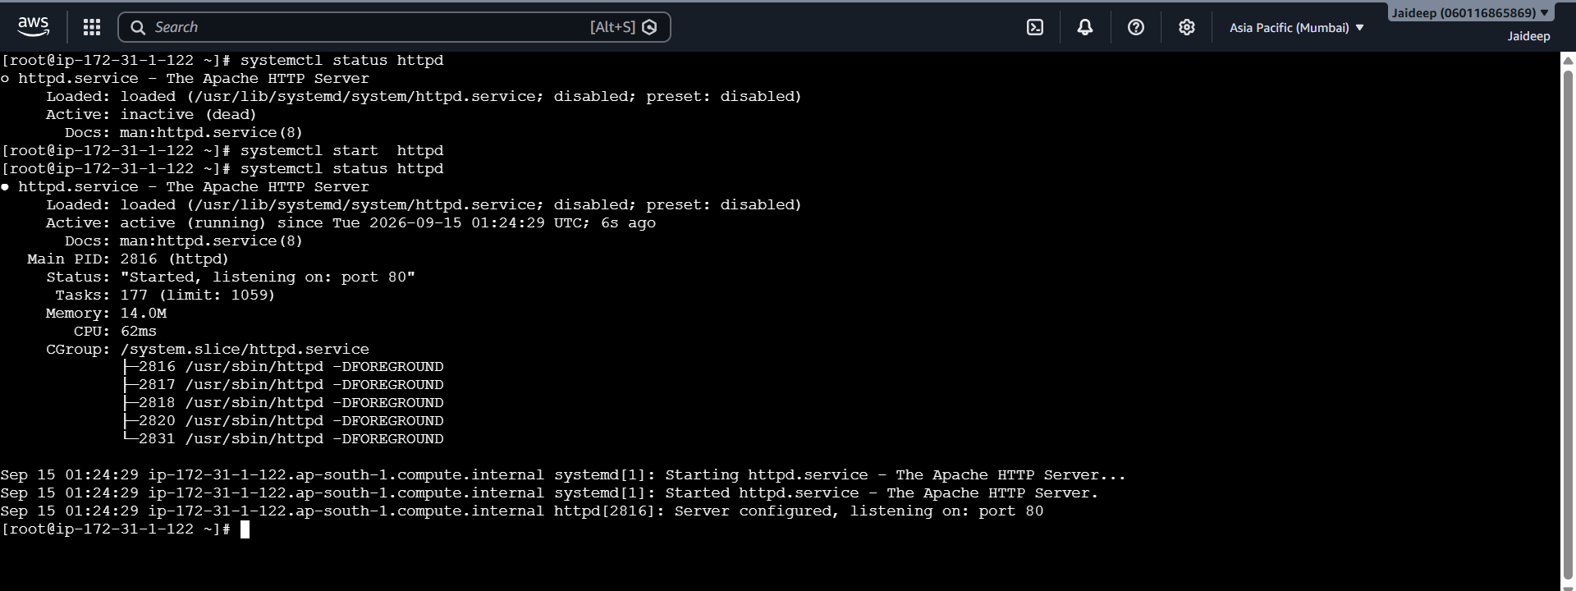
Step 8: Create the HTML Webpage
Apache uses the following directory to serve website files:
/var/www/html
Create the webpage:
nano /var/www/html/index.html

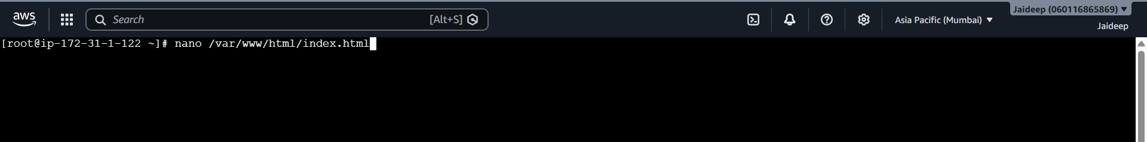
Enter the following HTML code:
<html>
<head>
<title>
Jaideep's Website
</title>
</head>
<body>
<p>Greetings!</p>
<ul>
<li>Author: Jaideep</li>
<li>Hosted on: Amazon EC2 Instance</li>
</ul>
</body>
</html>

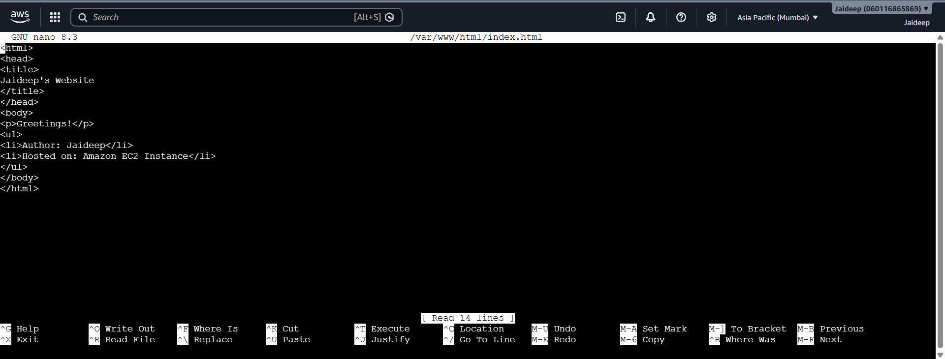
Save the file as:
/var/www/html/index.html
Step 9: Verify the Web Server
Check the Apache service:
systemctl status httpd
The status should indicate that httpd is running.
The webpage file is located at:
/var/www/html/index.html

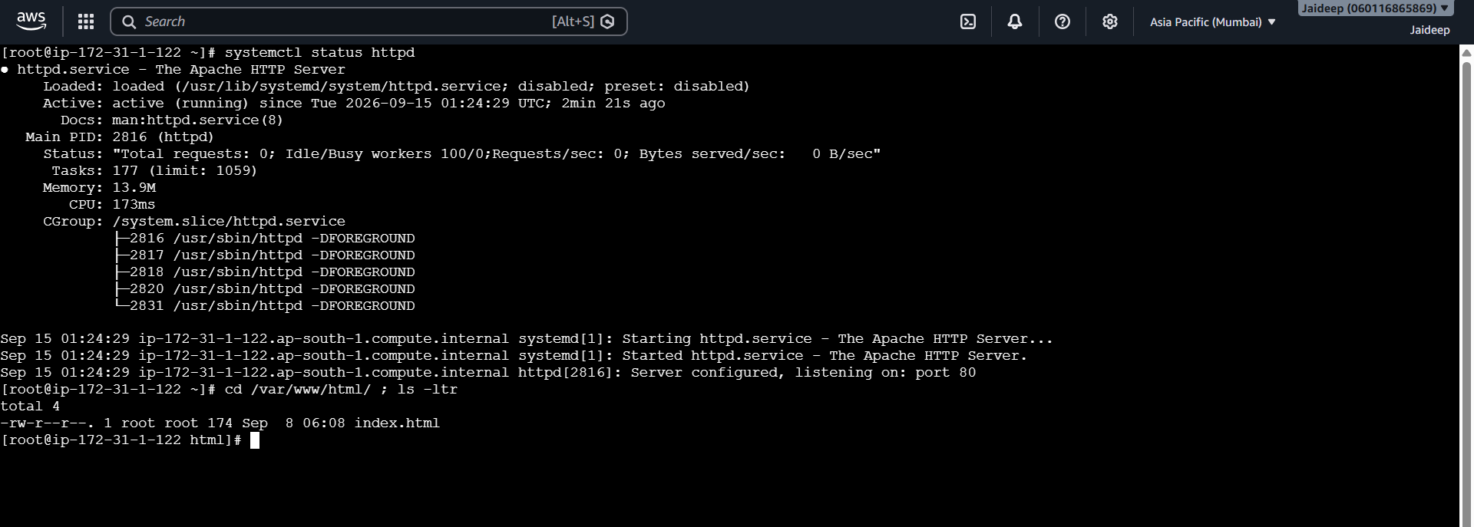
Step 10: Access the Webpage
Open a web browser and enter the public IPv4 address:
http://<ipv4_address>
The browser displays the webpage containing:

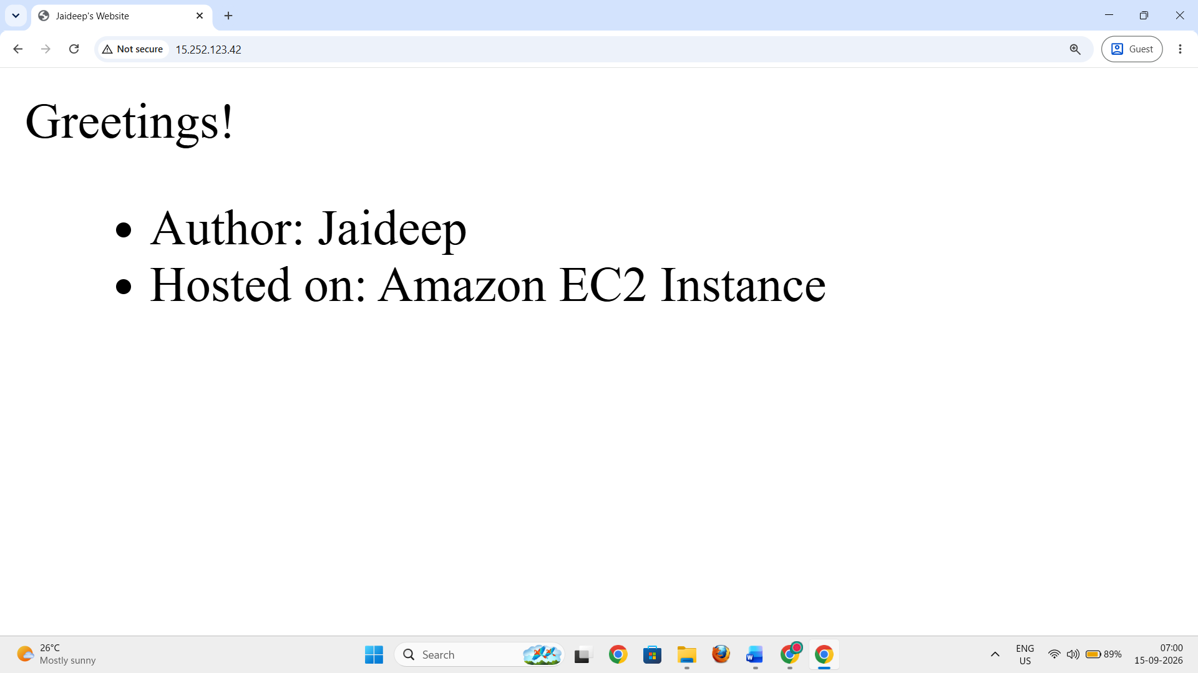
The webpage is served by Apache through HTTP port 80.
6. Commands Used
Operation | Command
Switch to root user | sudo su -
Update packages | yum update
Install Apache | yum install httpd -y
Start Apache | systemctl start httpd
Check Apache status | systemctl status httpd
Web root directory | /var/www/html
HTML file | /var/www/html/index.html

7. Result
The Amazon EC2 instance is successfully launched with Amazon Linux and accessed through EC2 Instance Connect. The Apache (httpd) web server is installed and started, and the index.html file is hosted in /var/www/html.
The HTML webpage is successfully accessible through the EC2 instance's public IPv4 address using a web browser.

